Order Dashboard:

Goal to Give Our Customers the Ability to Save their client information in our system so that ordering repeat products can just 1 click import the client details.

The Order Dashboard should integrate with our product purchasing / shopping cart:

Example #1:

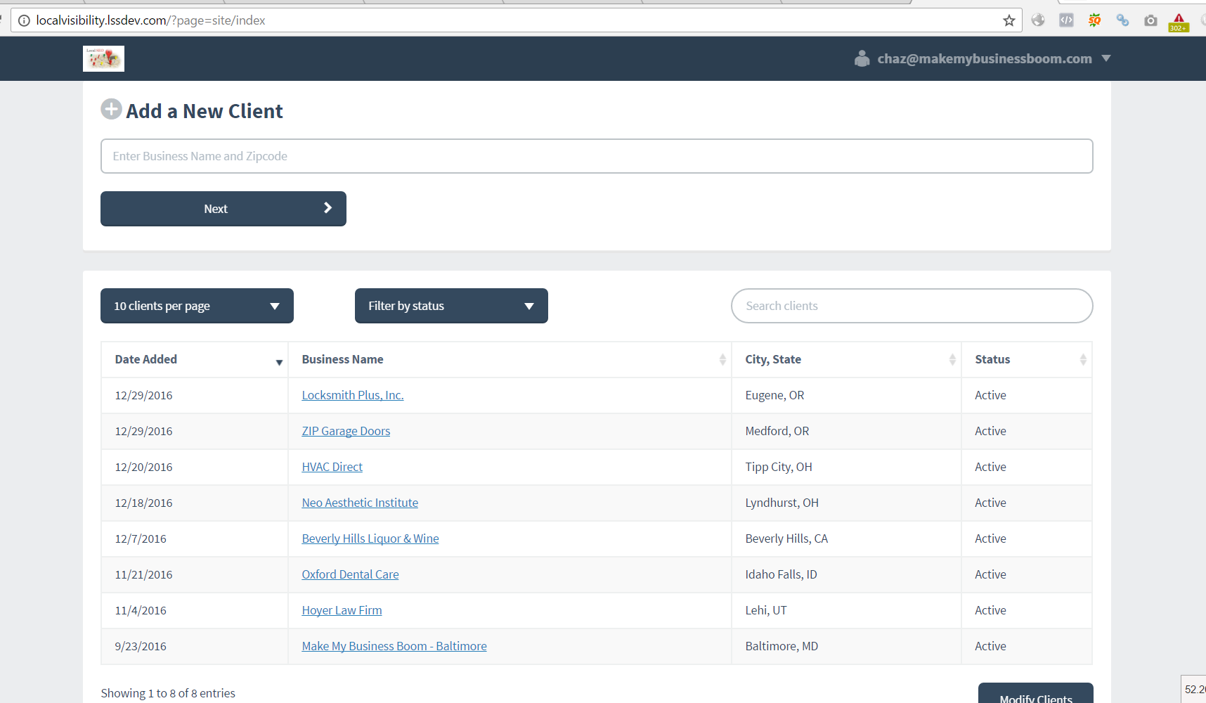

(ability to add customers within your own account)

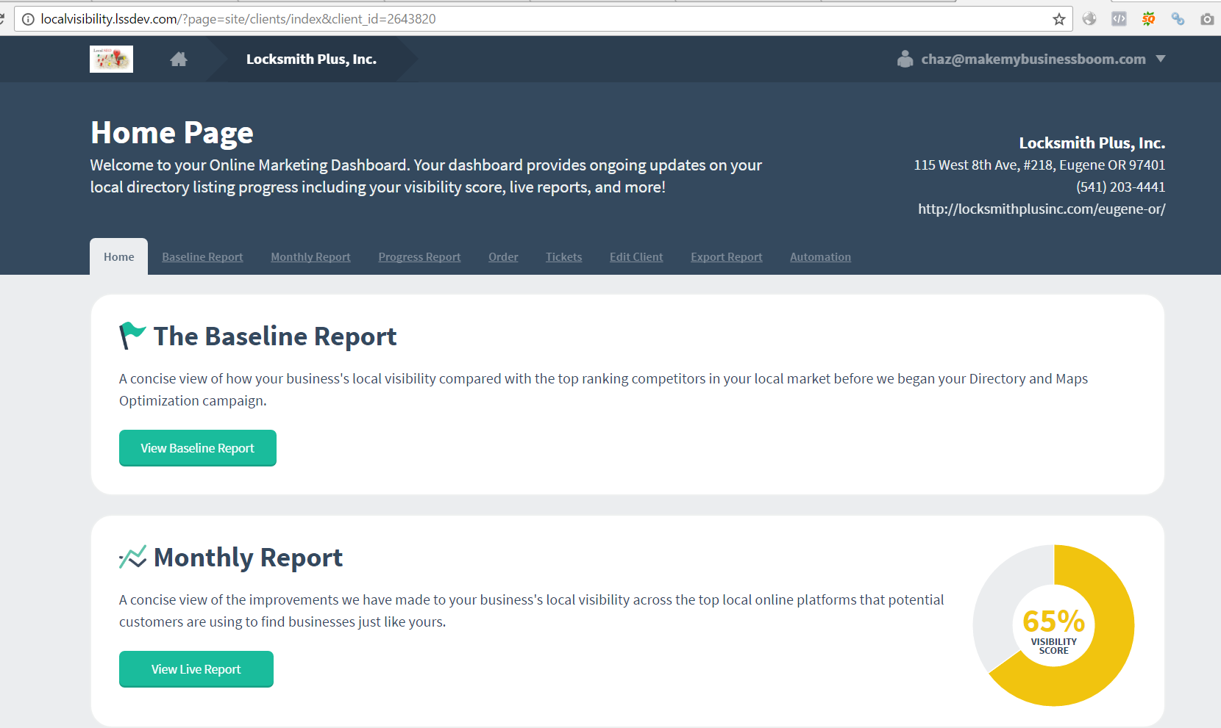

(has a spot to deliver order reports and also can order new services for the client)

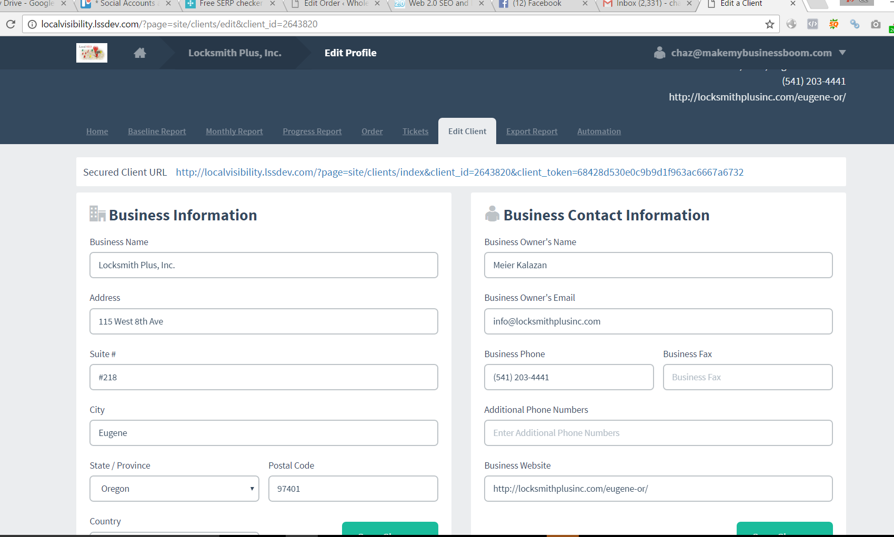

(has a space for all needed customer details for a campaign)

Example 1: http://localvisibility.lssdev.com/

UN: chaz@makemybusinessboom.com

PW: D@ddy123

Example #2:

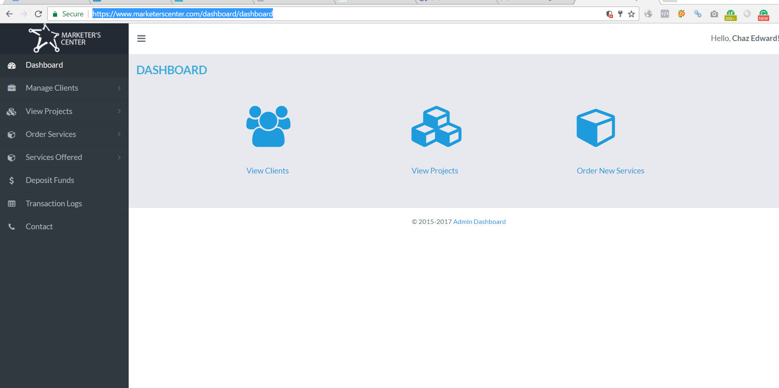

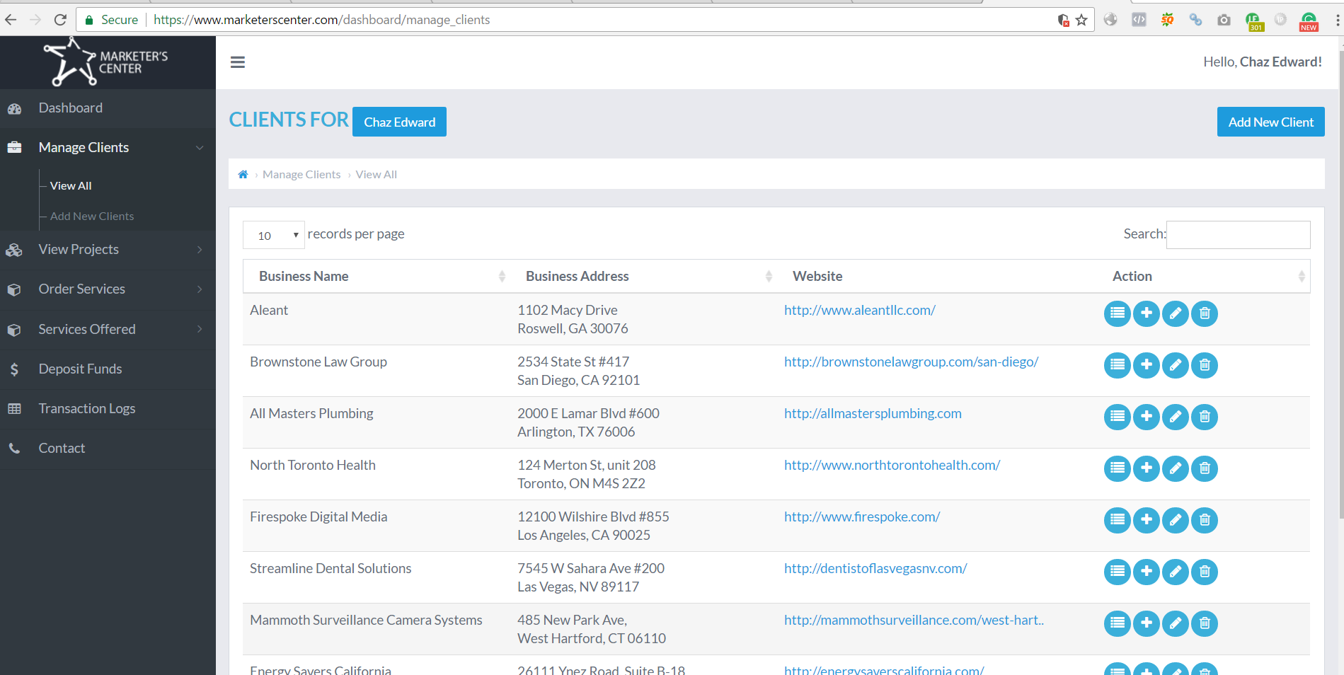

(easy to add clients and see clients)

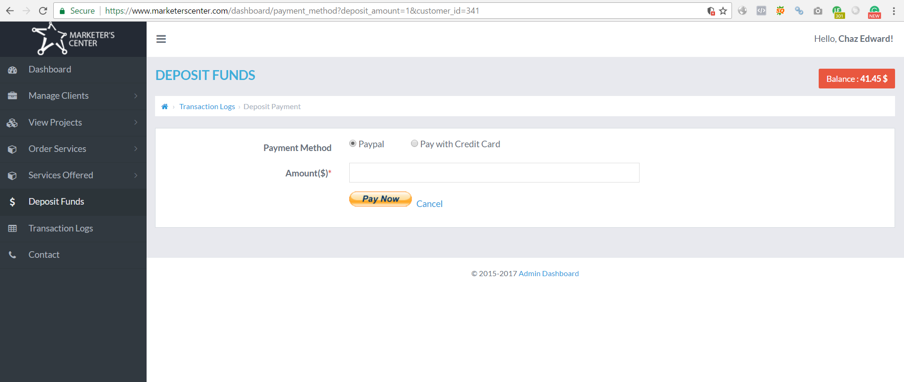

(ability to deposit funds – we like this!)

**THINGS WE DON’T LIKE…**

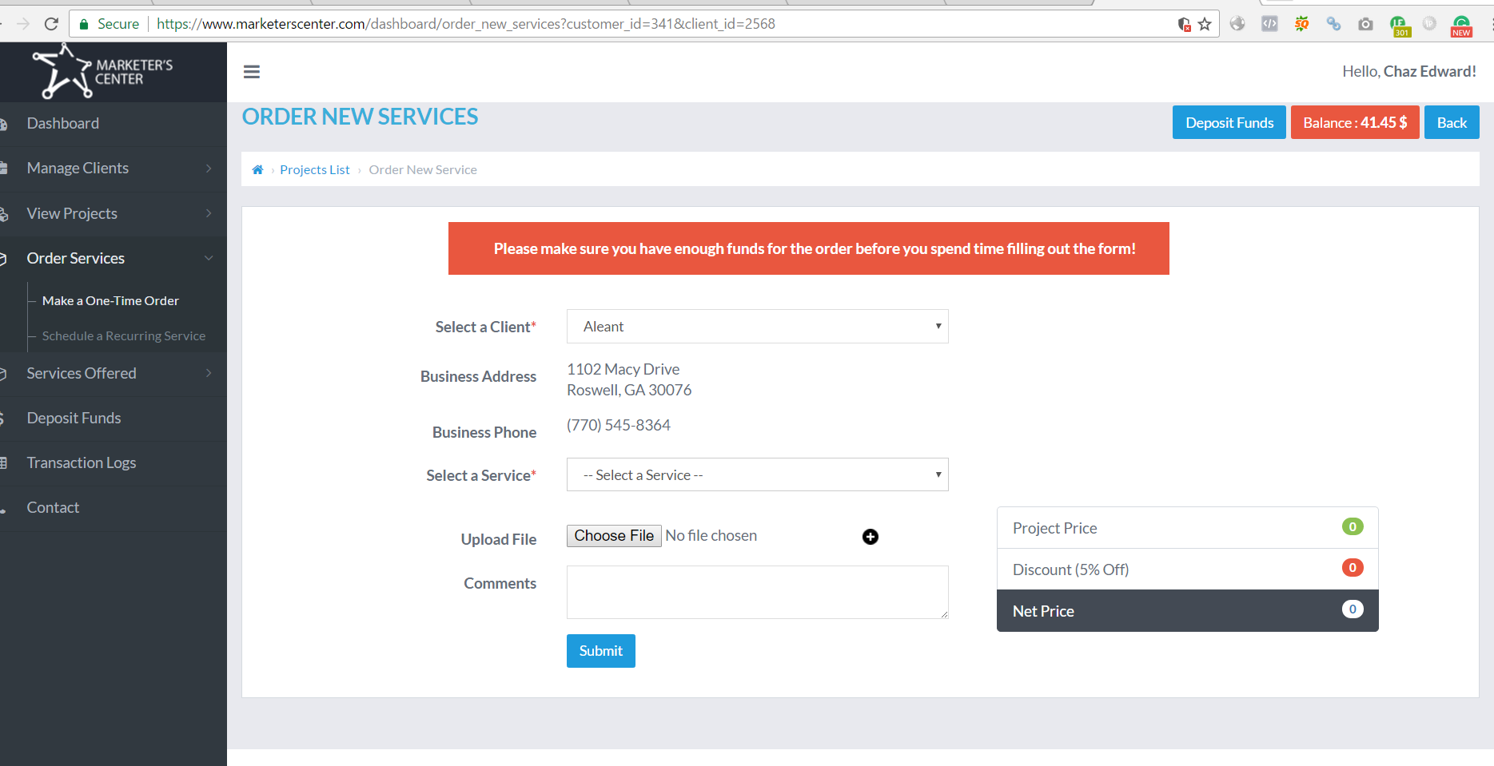

1. No option to pay with PayPal like a normal shopping cart. We want 2 options to pay #1: paypal #2 use deposited amount
2. We don’t like the order interface – no way to really tell what the product is you are ordering
3. Should be a normal product page and after ordering you have the option of 1 click importing the existing client info to the info submission form.

<https://www.marketerscenter.com/dashboard/index>

UN: chaz

PW: D@ddy123